**Week 4 Studio**

**Assessed Preparation**

Problem 1:

1. The worst case complexity of Quicksort is O(n^2) when we select the first element of the sequence because every element will be on the right of the pivot.
2. Selecting the minimum element of the array results in having O(n) levels of recursions and O(n) work to do the partition. It will run in O(n^).
3. O(nlogn) because selecting the median as the pivot is the ideal case because one half of the array is greater than the pivot and the other half is less. It results in log(n) levels of recursions since array is halved at each level.
4. 90th percentile : (9/10)^d *n = 1

d = $\log_{0.9}{n}$

O(n $\log_{0.9}{n}$) = O(nlogn)

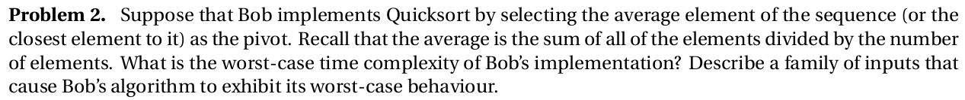

[1,2,3,4,1,2,3, 1000]

Test case:

Average = approx 55

Closest to 55==1000

This means that we will only be reducing the size of the input to the next iteration by 1,

Hence the worst case time complexity O(N^2)

This also applies

list1= [1,2,3,4,1,2,3], list2[1000]

[1000,1,1001,2,1002,3,1003,4]

Iteration 2=

[1,2,3,4] and [1000,10001, 1002, 1003]

1. Values spread approx. evenly over data set
2. Clustering very small and very large chunks

Think about the sequences such that we get exponential growth (fast growing sequence value)

Factorial?

[1,2,6,24,...]

1, 2, 4, 8, 16 ….



Kth smallest element will be in array [n/4, n/2, n/4]

Quickselect returns the kth smallest element in array

If we select the smallest pivot in the n/2 sub array, the array reduces in size by ¾ and we quick select to the right.

First iteration O(n)

Second iteration O(3n/4)

Third iteration O(9n/16)

a(1 + r + r2 + ... + r(n-1))

Nth Iteration O(n + 3n/4 + 9n/16 + …) = n*(¾)x = (1 -

*apply the concept of a geometric sequence to logic

a(1-r^n / 1-r) <= **a(1 / 1-r)**

a = n

r = 3/4

Geometric sequence is bounded by 4*n



Quickselect will return the kth smallest element in O(n)

Does this include the median?

[4, 5, 1, 10, 11]

N = 5

Median = 5

So find median THEN find kth closest number to that.

[5,4,7,8,3,2,1,5,10] what is the median? The 5th smallest number

K = 5

[1,2,**3**,**4**,**5,5**,**7**,8,10]

[(**0,5)**,(**1,4)**,(**2,7)**,(3,8),(**2,3)**,(3,2),(4,1),(**0,5)**,(5,10)]    Distance to median. *We want the k smallest numbers in this list.*

Find the k-th smallest number in this list. The 5th smallest is 2 O(n)

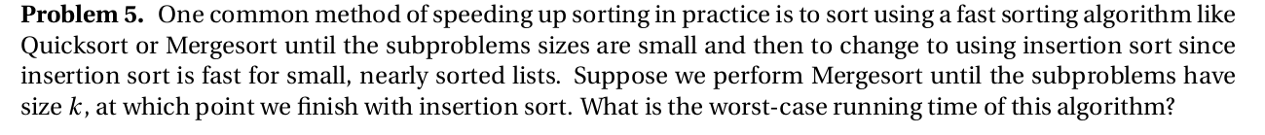

Merge sort until size k -> O(logn)

Insertion sort is O(n) best case, O(n^2) worst case

Merge sort is O(N logN) best case, O(N logN) worst case

Depth of log(n/k)

Here do we have merge sort worst case until k + insertion sort worst case for k

a)

Radix sort: O((n) * (M))

za__

aa__

zaa_

aaa_

abae

faca

How many times do we call count sort: m times where m is the length of the longest string

Count sort: O(n) where n is the number of strings

Time complexity: O(nm)

A____________________________

A____________________________

A____________________________

A____________________________

A____________________________

A____________________________

A____________________________

A____________________________

A____________________________

A____________________________

A____________________________

ABASUIOBFAIFBAIYFBAHFBASDFASA

S strings

N total characters

S = (n+1)/2

b)

1 Za

2 Aa

3 Zaa

4 Aaa

5 Abae m

6 Faca

J = 4, the column we are currently wanting to sort

M = 5, every string below index 5 has at least 4 characters

1 Za

2 Aa

3 Zaa m

4 Aaa

5 Faca

6 Abae

J = 3, the column we are currently wanting to sort

M = 3,

1 Za m

2 Aa

3 Zaa

4 Aaa

5 Abae

6 Faca

J = 2, the column we are currently wanting to sort

M = 1

1 Za m

2 Aa

3 Zaa

4 Aaa

5 Faca

6 Abae

J = 1, the column we are currently wanting to sort

M = 1, sort strings m..n based on j-th character

Value of m tells us from this point on sort elements in column j.

1 Za m

2 Aa

3 Zaa

4 Aaa

5 Faca

6 Abae

1 Aa

2 Aaa

3 Abae

4 Faca

5 Za

6 Zaa

Length of string?

O(N) where N is the total number of characters

Problem is that its padding to the right of the string?

Empty spaces cannot be found

^(can adjust radix sort to handle empty as space





